PROJECT 1 – Automating infrastructure using terraform

1. Click on Devops in AWS V2 and click on launch lab at the bottom right.
2. Click on start instance
3. Click on the RDP access and access the machine with the auth url
4. Open the terminal inside the machine
5. Checking if the aws cli is working on the machine

aws --version

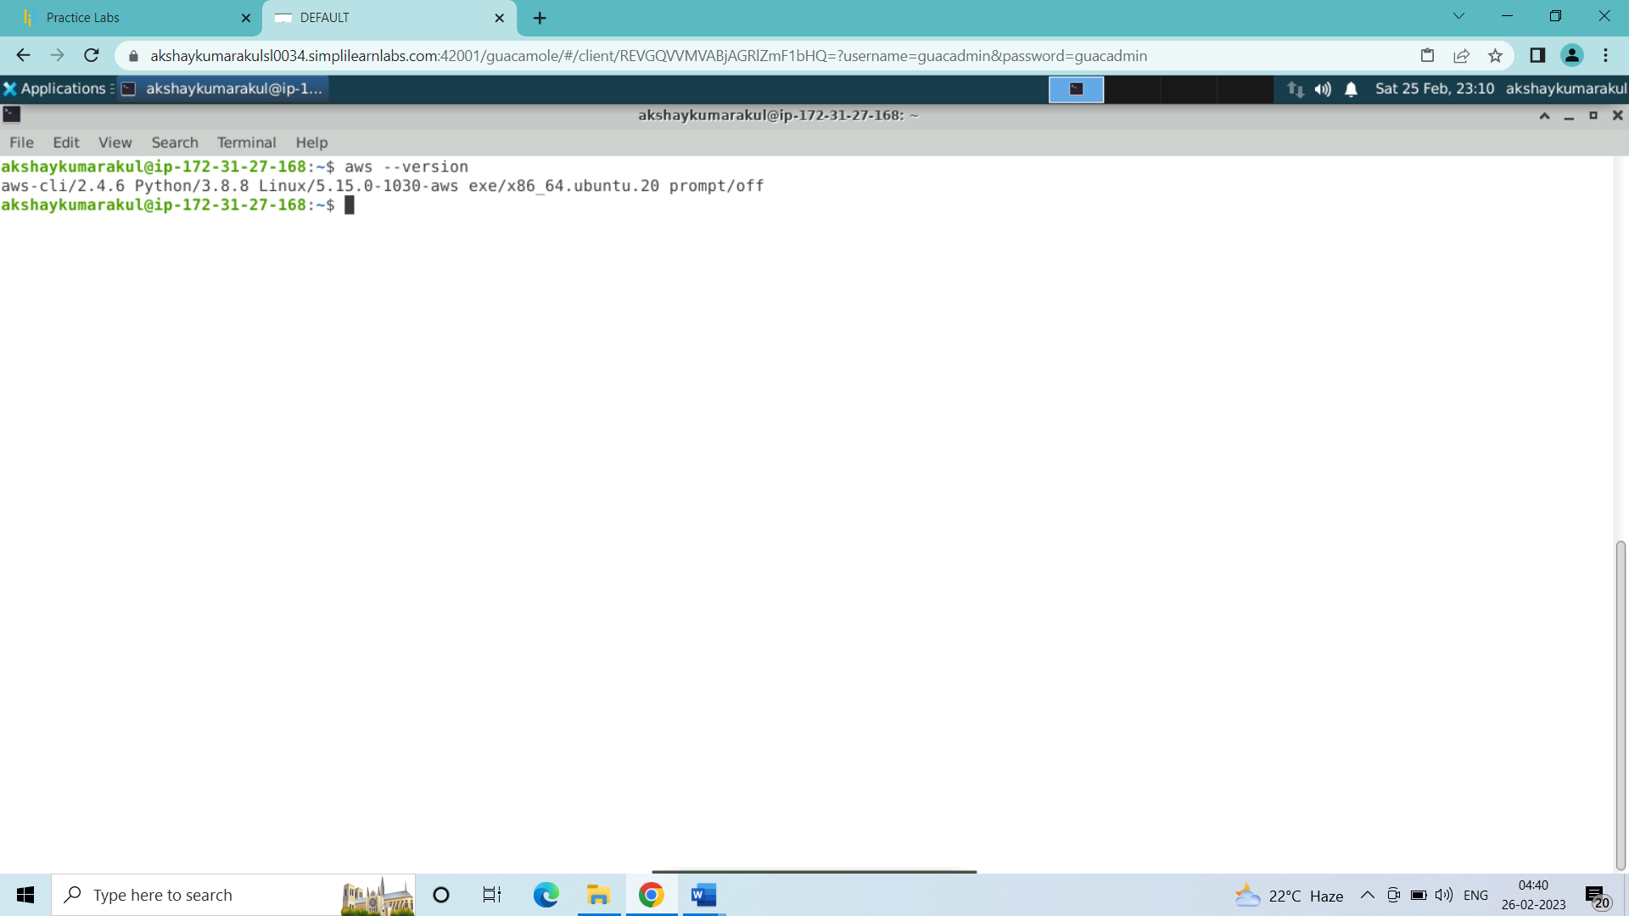

1. Check the terraform version and update it if required:

terraform --version

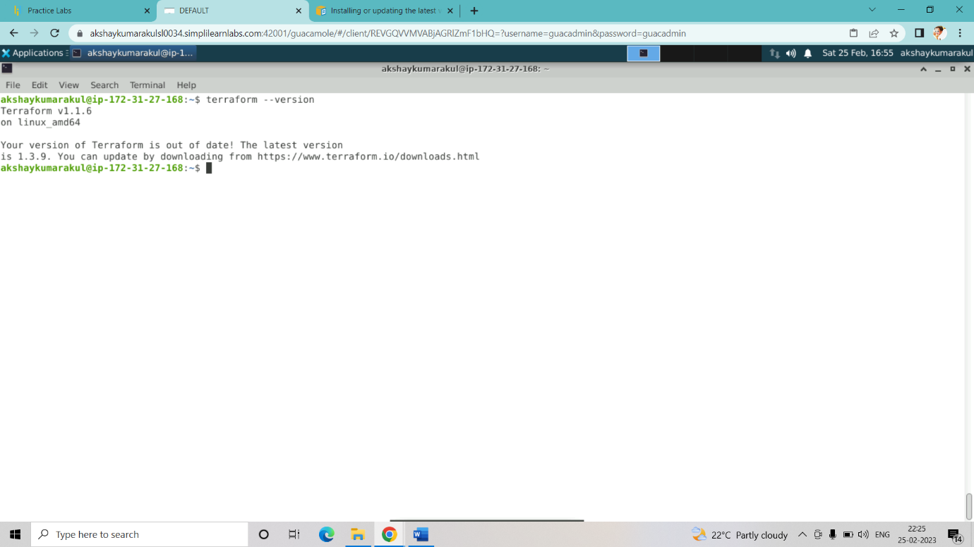

Since the terraform is not updated we will update the terraform first:

$ sudo su

$ apt update -y

Go to the link <https://developer.hashicorp.com/terraform/downloads>

And use the commands

1. wget -O- https://apt.releases.hashicorp.com/gpg | gpg --dearmor | sudo tee /usr/share/keyrings/hashicorp-archive-keyring.gpg
2. echo "deb [signed-by=/usr/share/keyrings/hashicorp-archive-keyring.gpg] https://apt.releases.hashicorp.com $(lsb_release -cs) main" | sudo tee /etc/apt/sources.list.d/hashicorp.list
3. sudo apt update && sudo apt install terraform

* updated terraform using the above commands

terraform --version

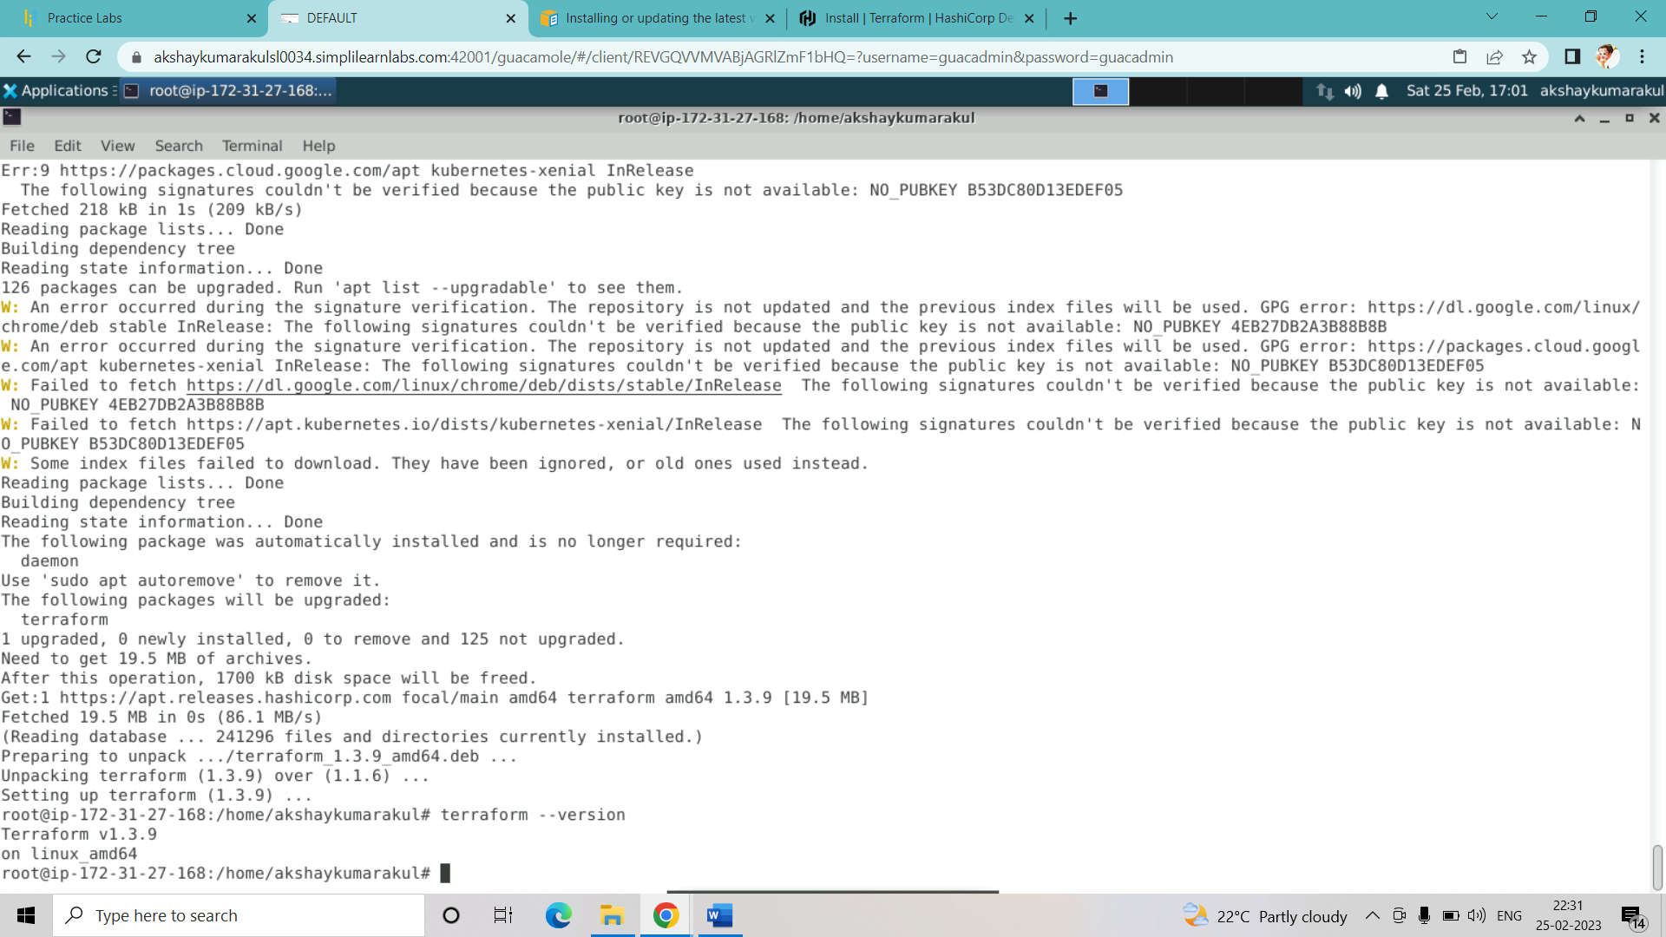

Checked the terraform version: terraform is now updated

1. now we connect our simplilearn machine with the aws account:

aws configure

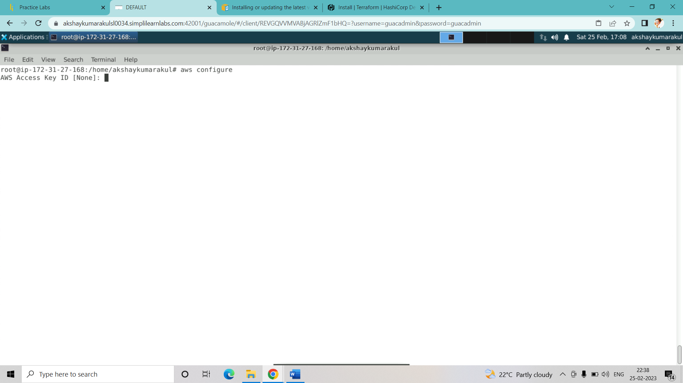

Access key is required to proceed:

Now I will go to aws account with which I will connect my Devops in AWS V2 lab

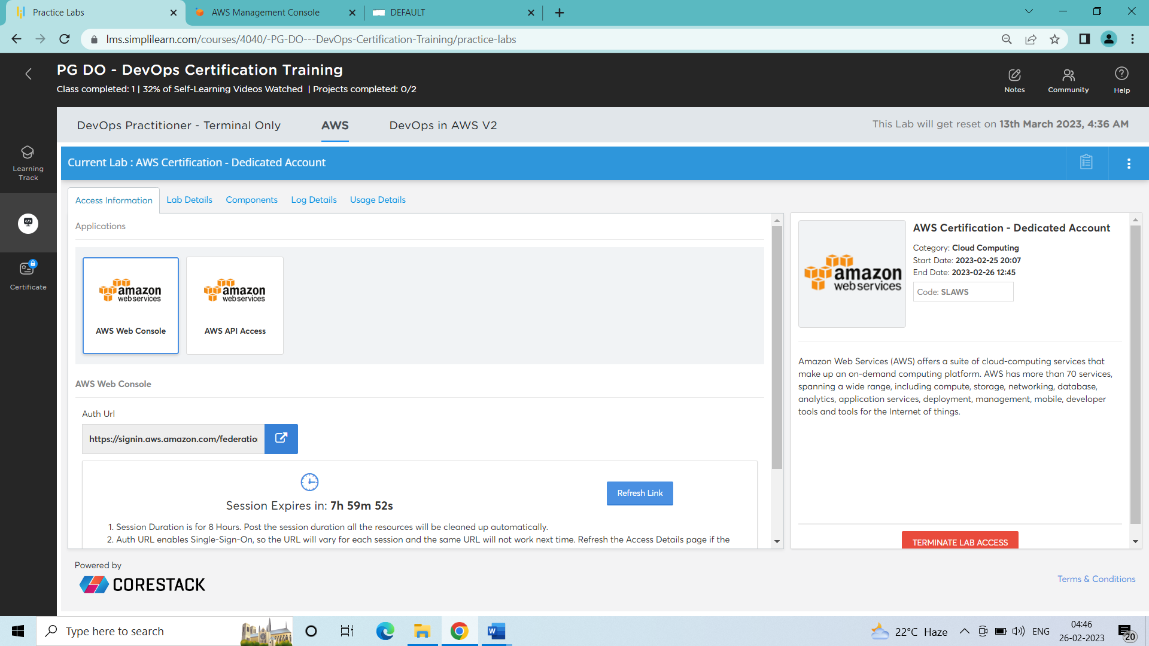

1. Inside the Aws account search for iam and get inside it

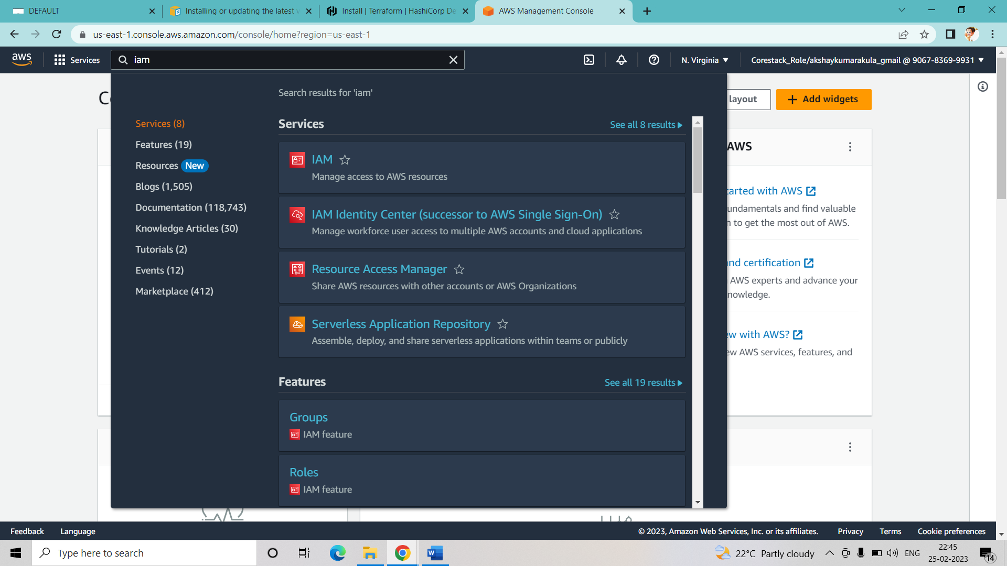

Click on users in the iam dashboard

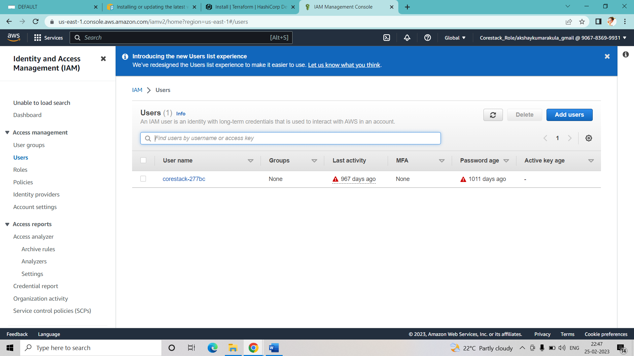

* Click on add user and provide username and click on next

My username – akshay

* Select attach policies directly and select admininstrator access and click on next

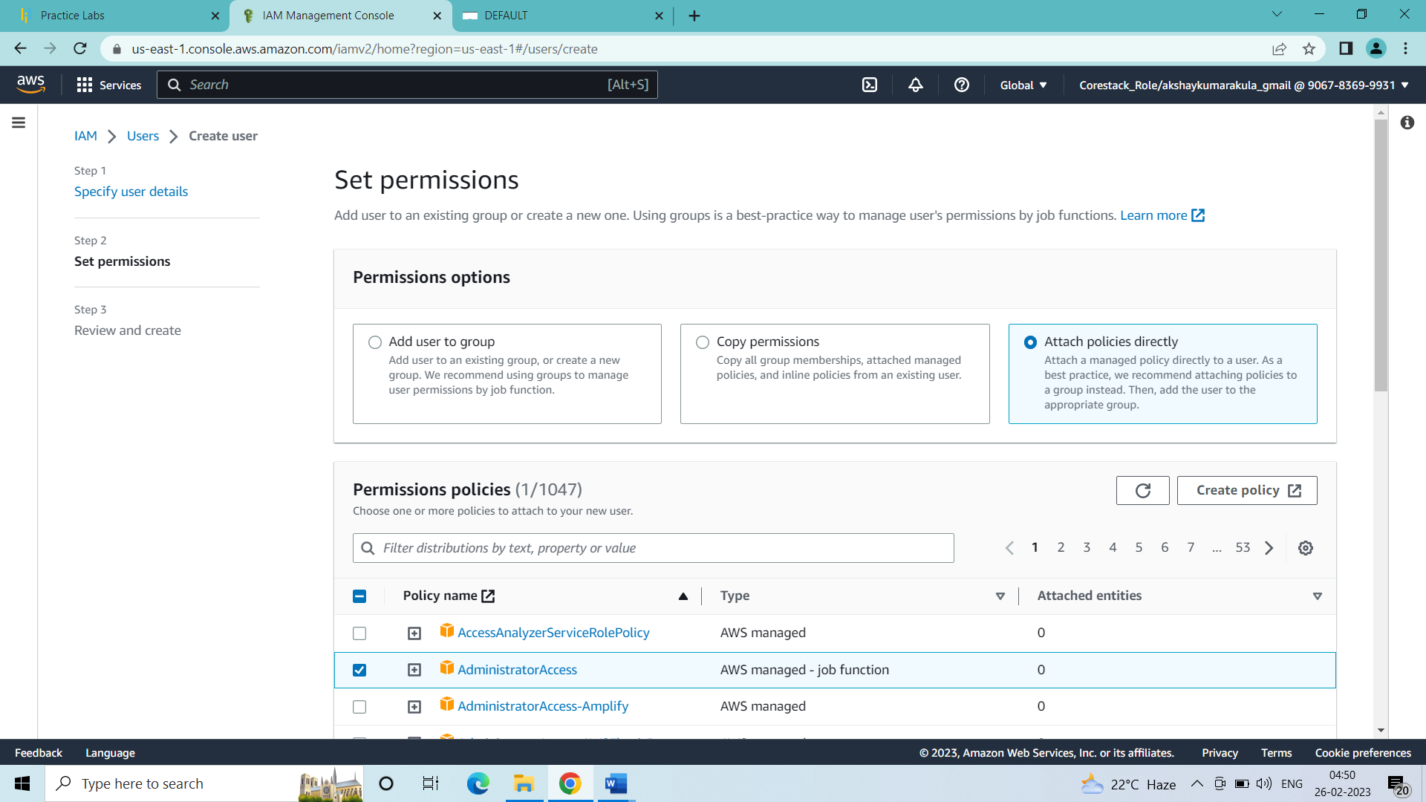

In the permissions summary click on create user

* Click on the user

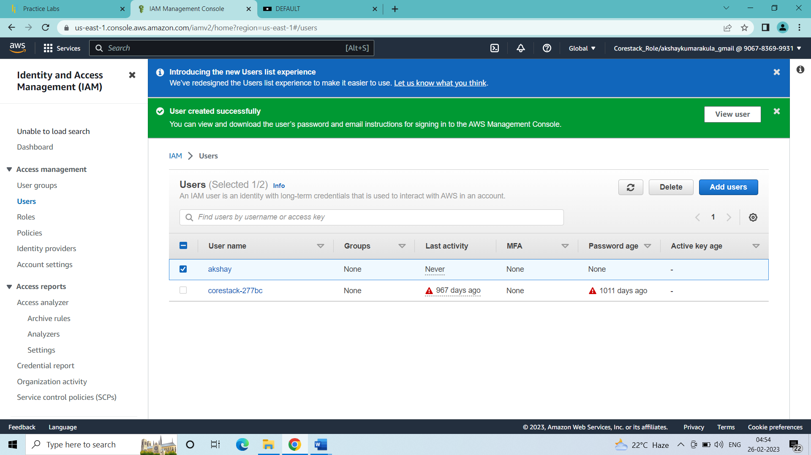

* Click on security credentials:

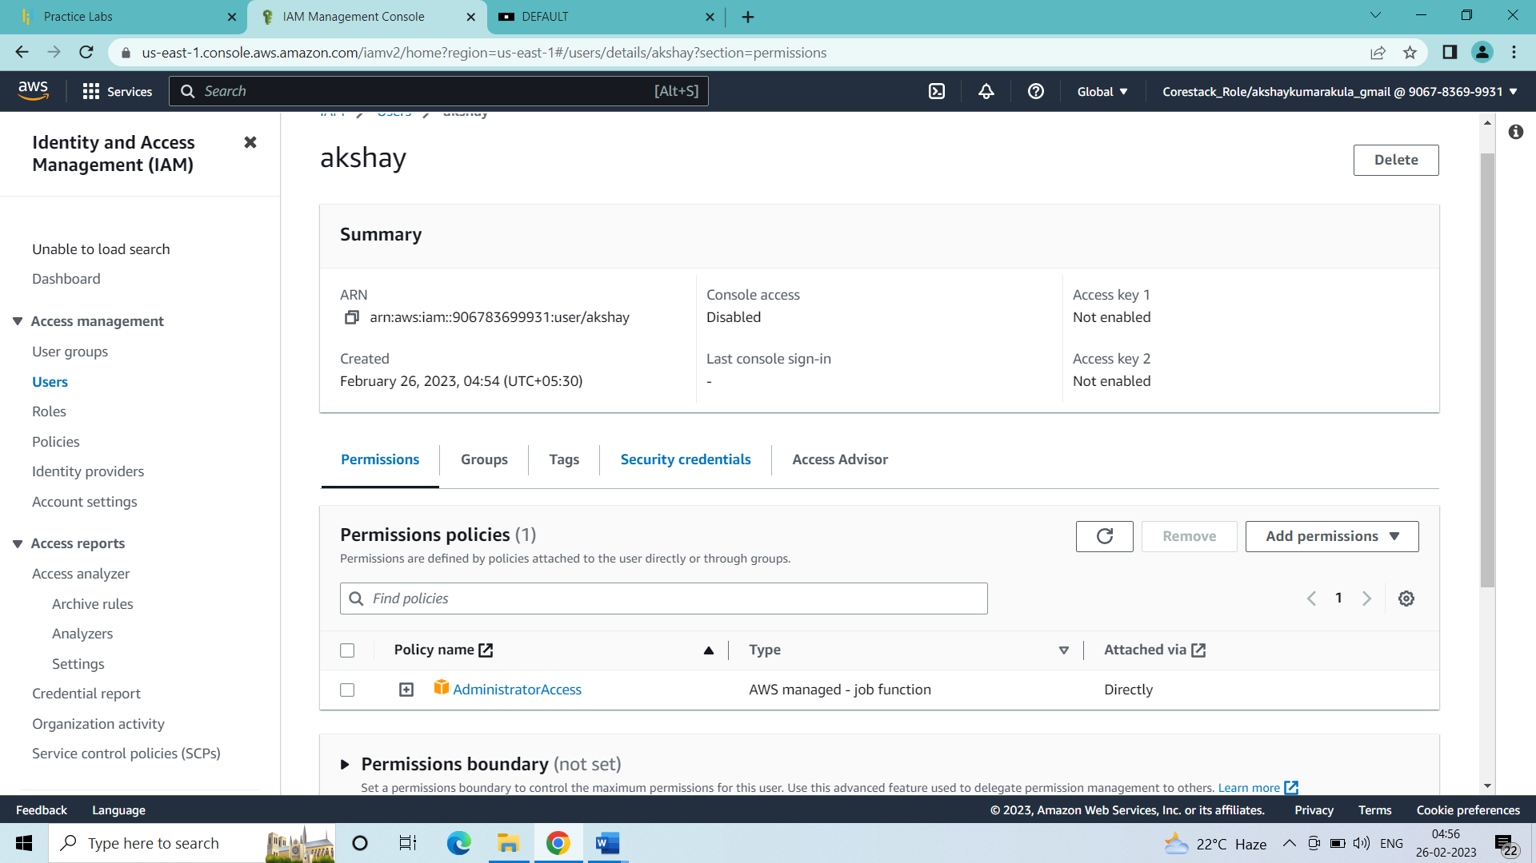

* Click on create access key

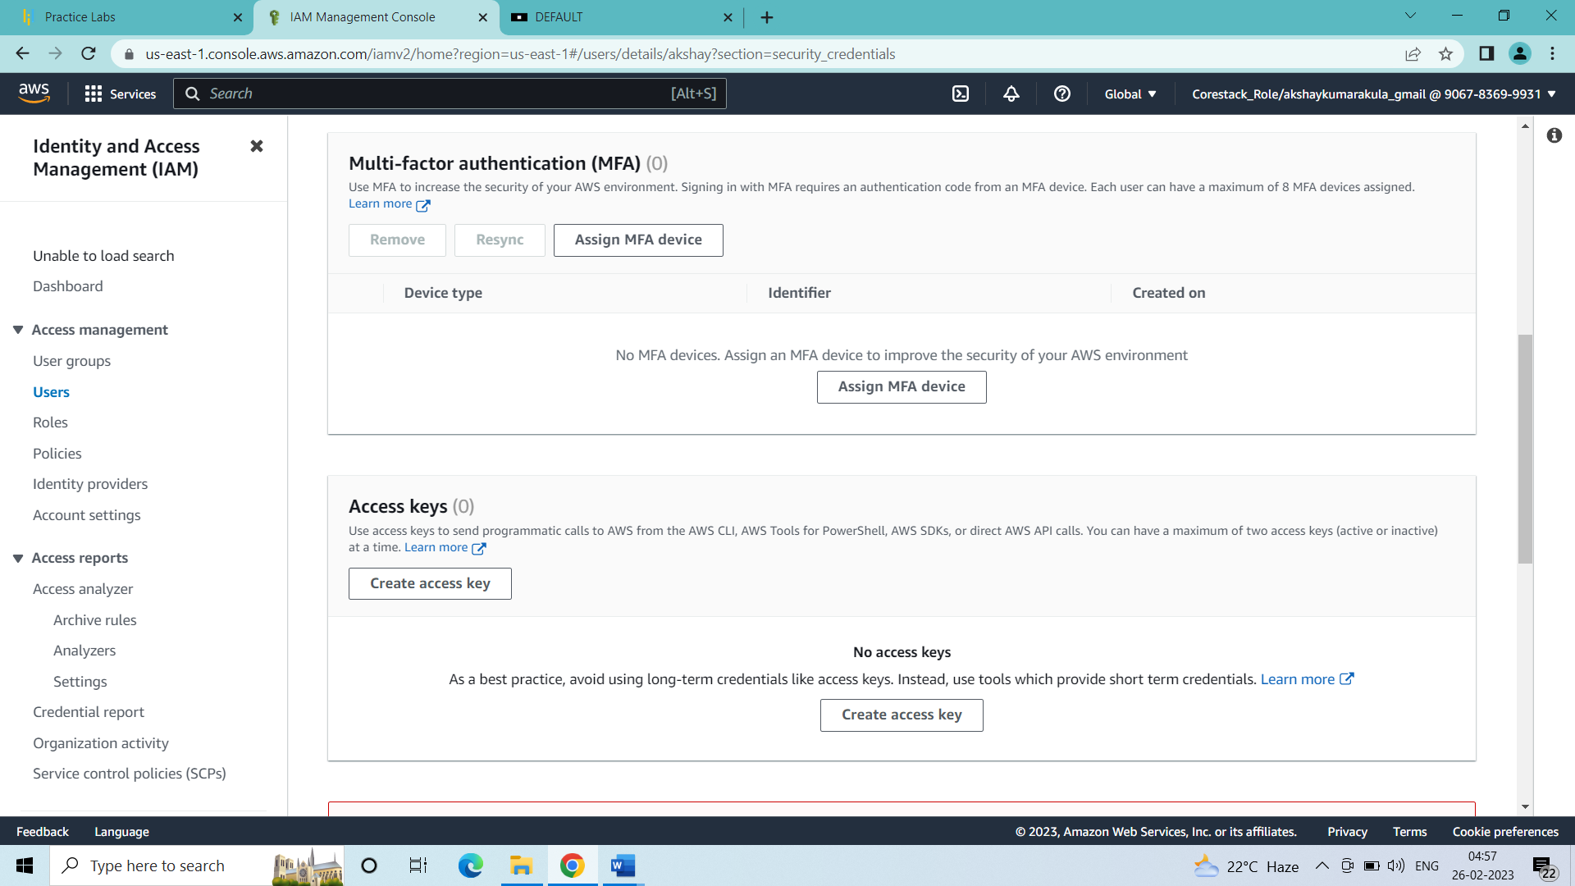

Select command line interface and press on next

* Set description tag and click on create access key

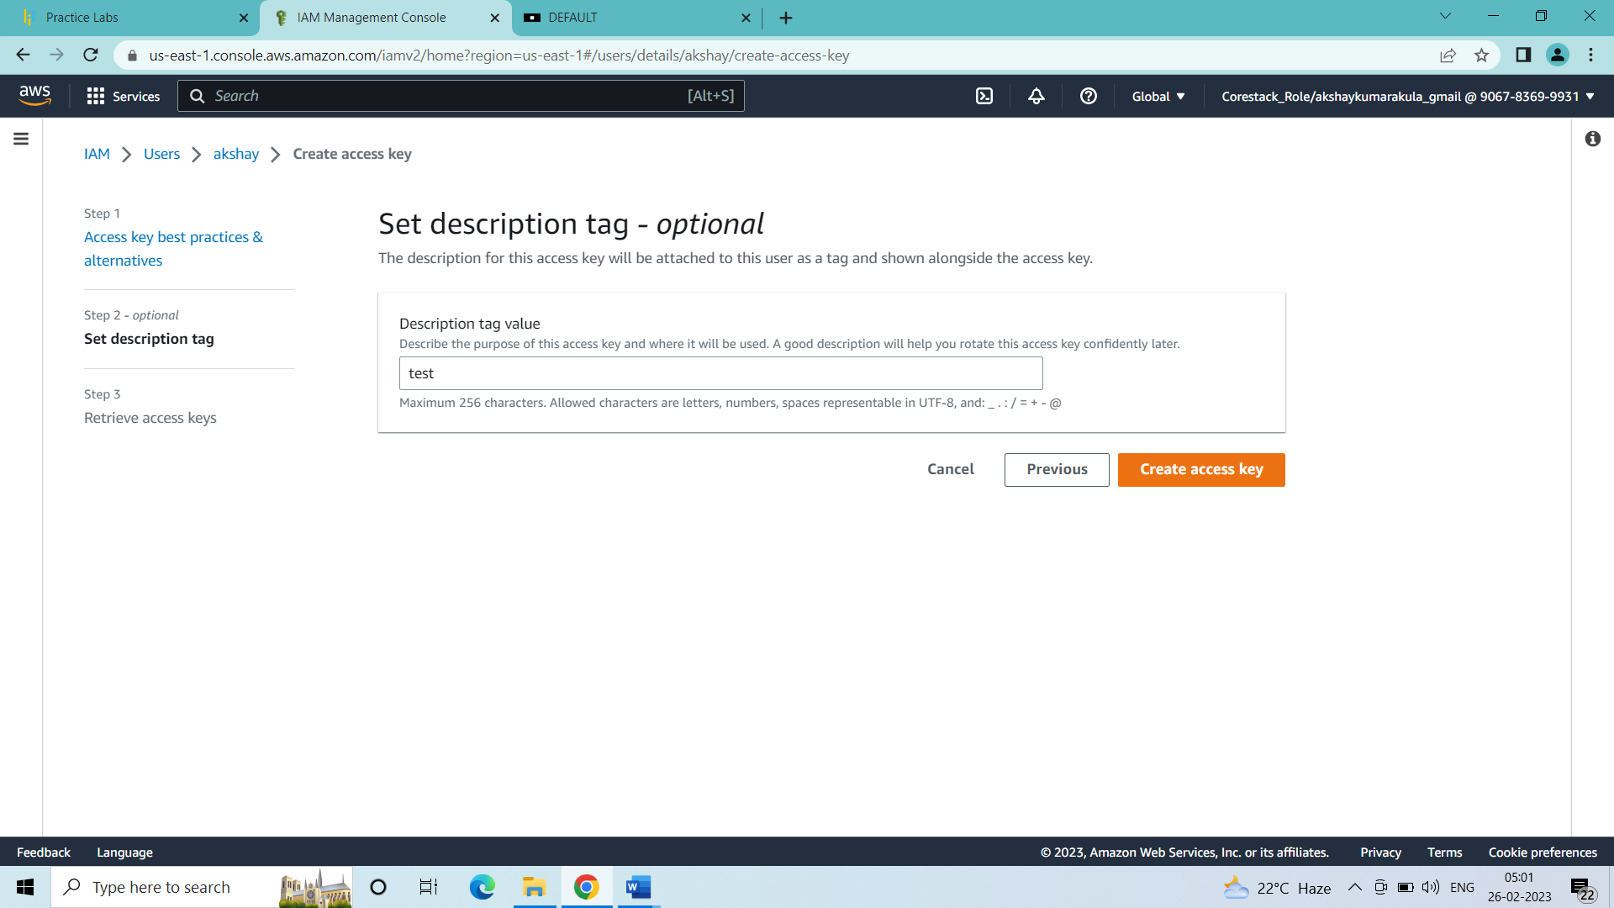

* Copy the access key and paste it in the terminal of the simplilearn machine
* After giving the credentials press only enter to keep region name, output format as default

1. First task is to write terraform code to create a new ec2 instance
2. We will create a new directory in the simplilearn lab machine

mkdir projectakshay

cd projectakshay

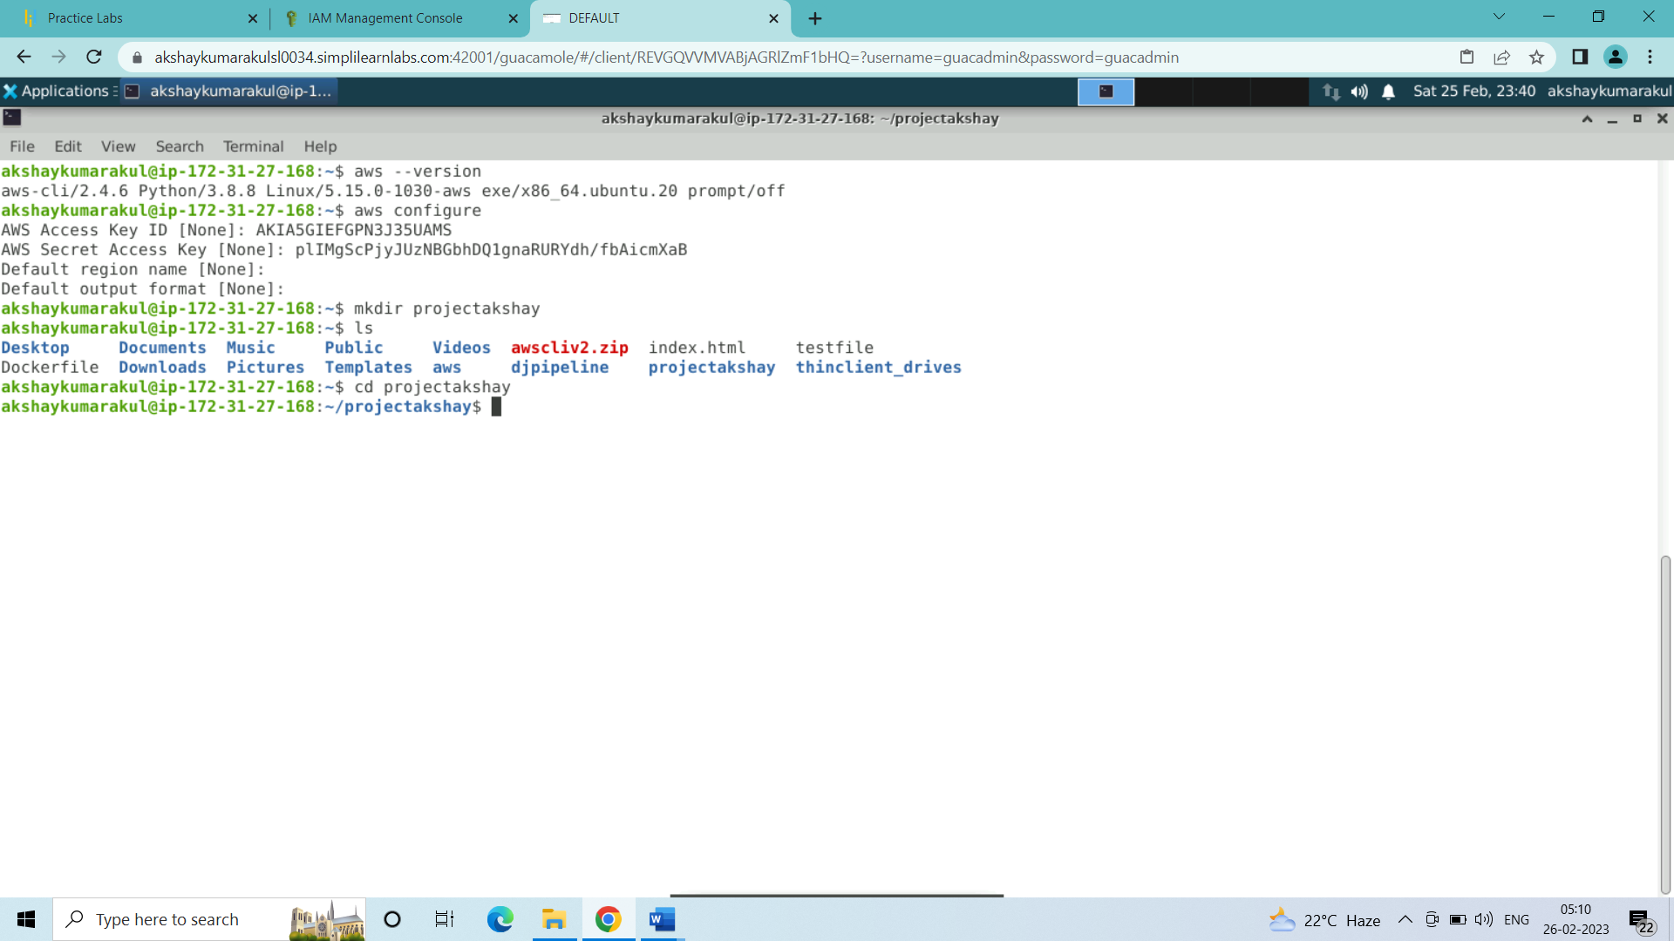

1. Now I will create a terraform file in which the code will be written to create my ec2 machine

vi ec2.tf

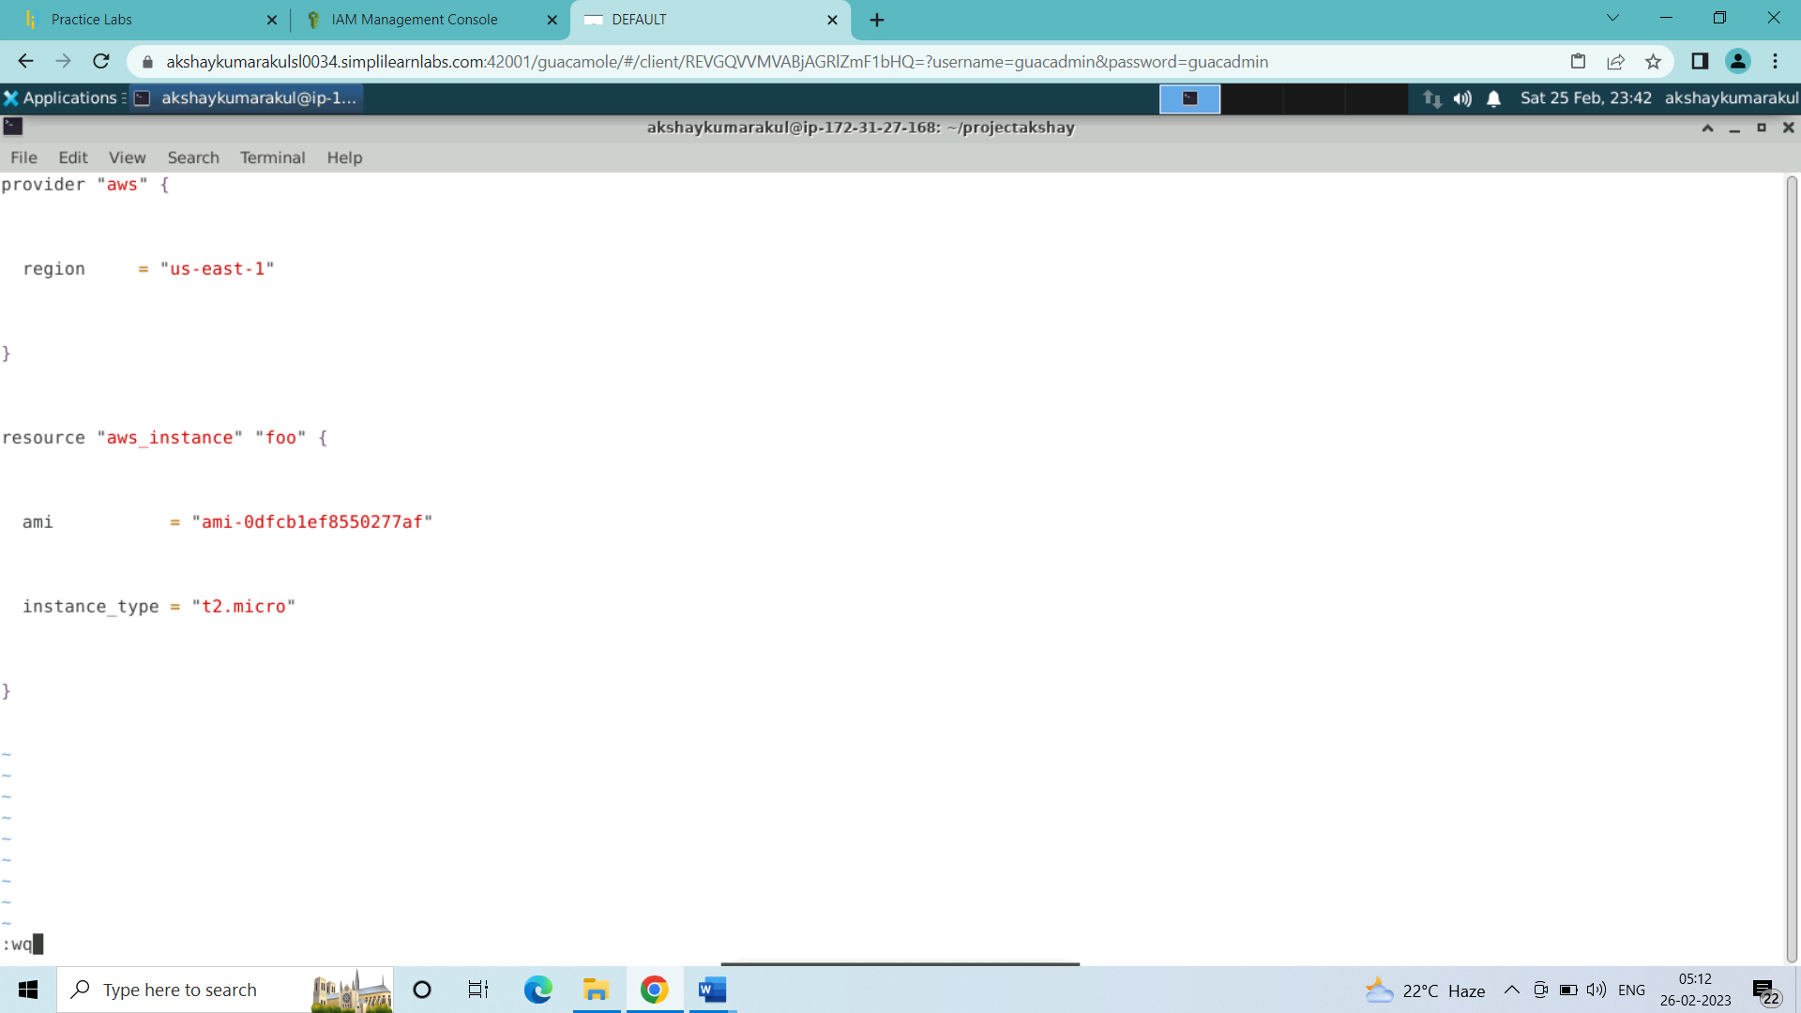

* Save and quit the file

:wq

1. Next initialize terraform registry in the directory:

terraform init

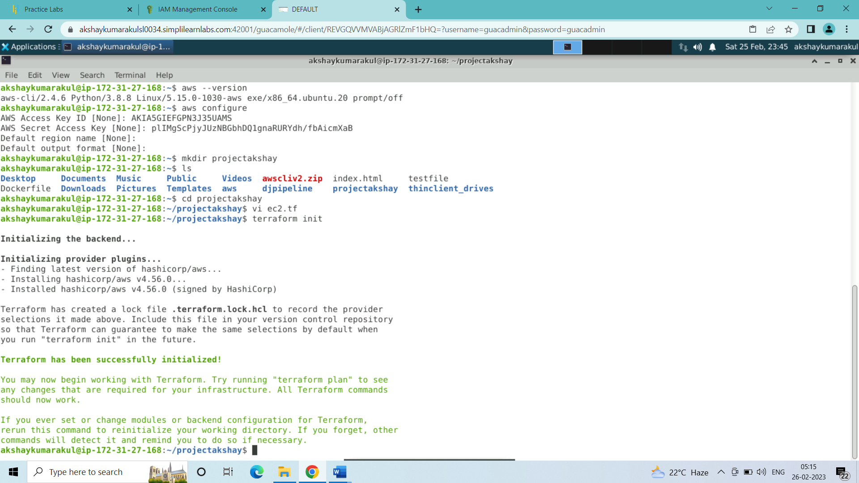

1. After initiating execute the terraform plan

terraform plan

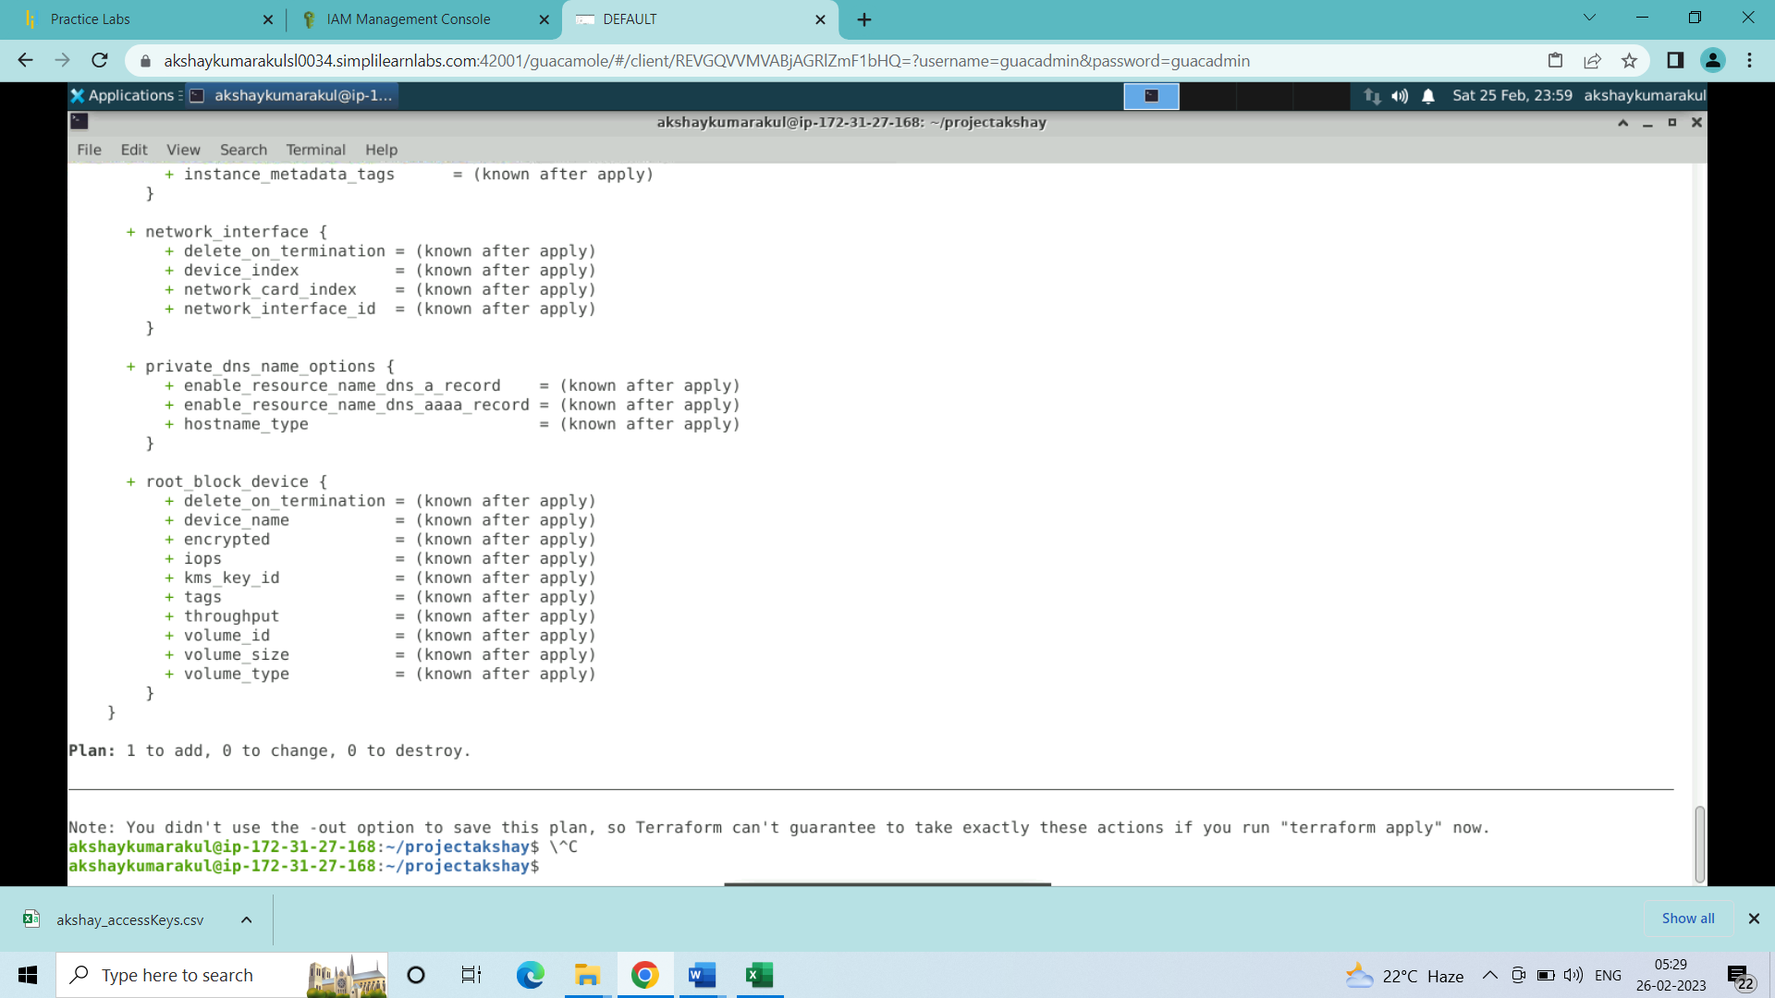

1. Now apply the terraform plan:

terraform apply

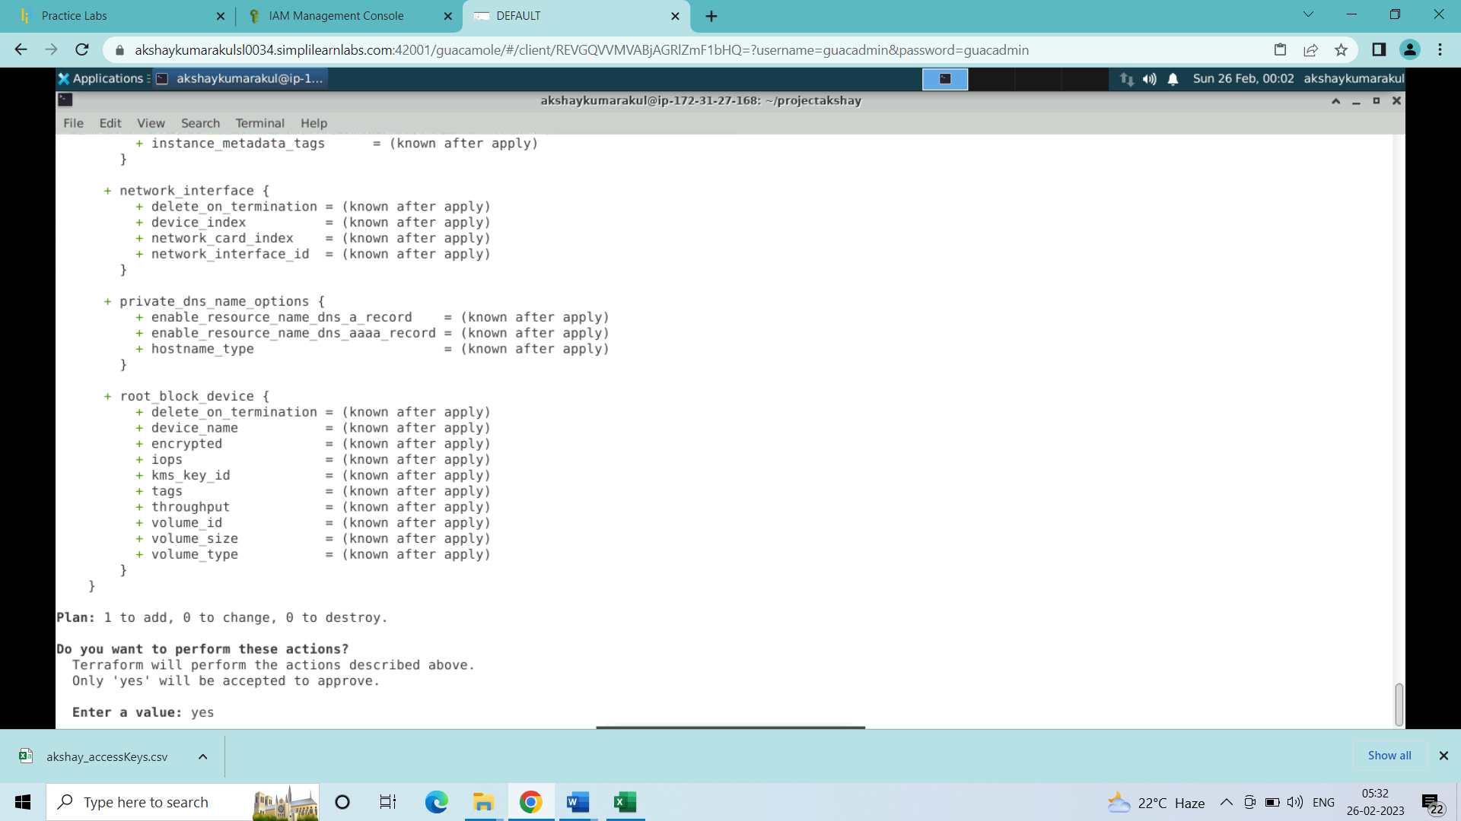

Value to be entered: yes

1. Ec2 instance created:

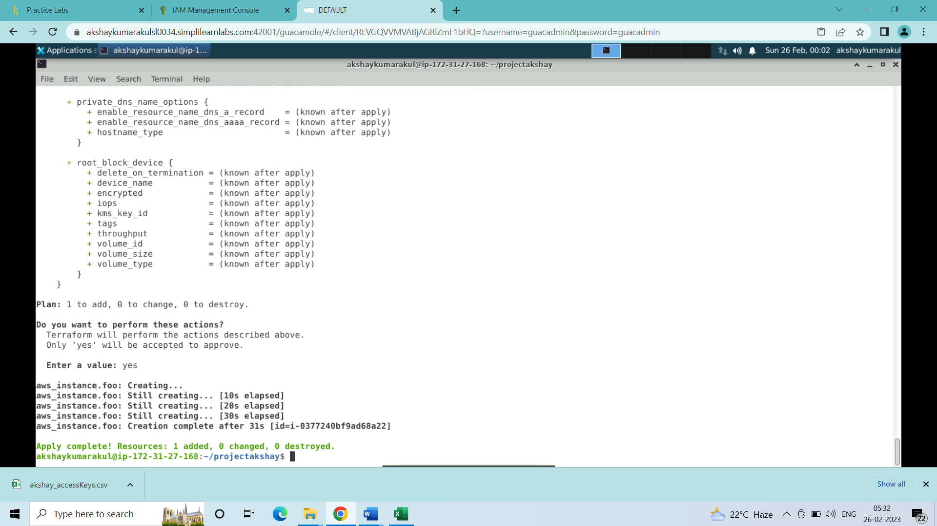

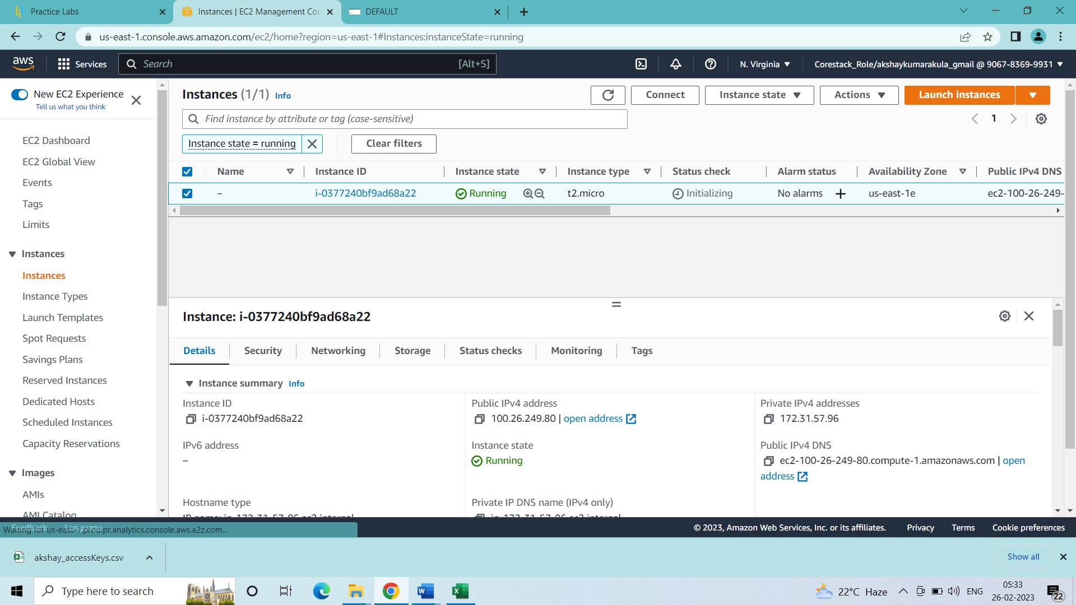

1. Edit inbound rules and add all traffic from anywhere IPv4:

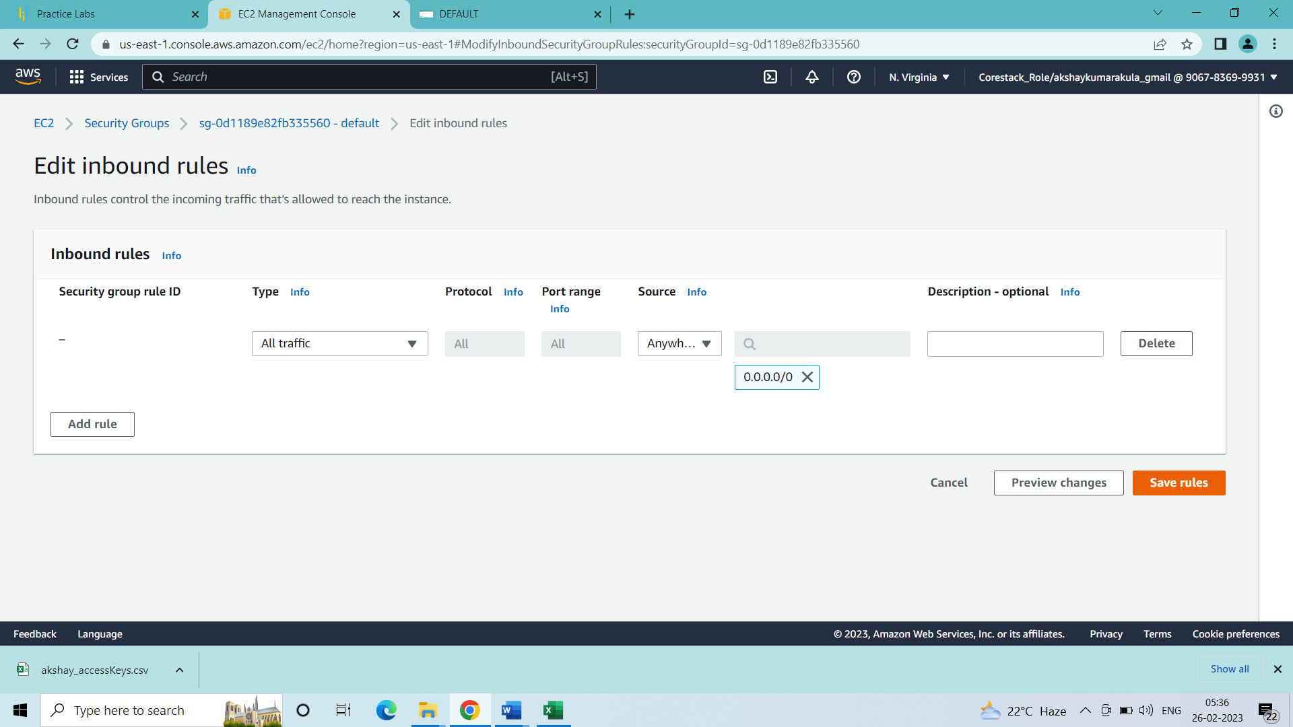

1. Now connect to the newly created machine and login

* Inside the new machine:
* Python installation:

sudo su

yum install <https://dl.fedoraproject.org/pub/epel/epel-release-latest-7.noarch.rpm>

yum install python -y

python –version

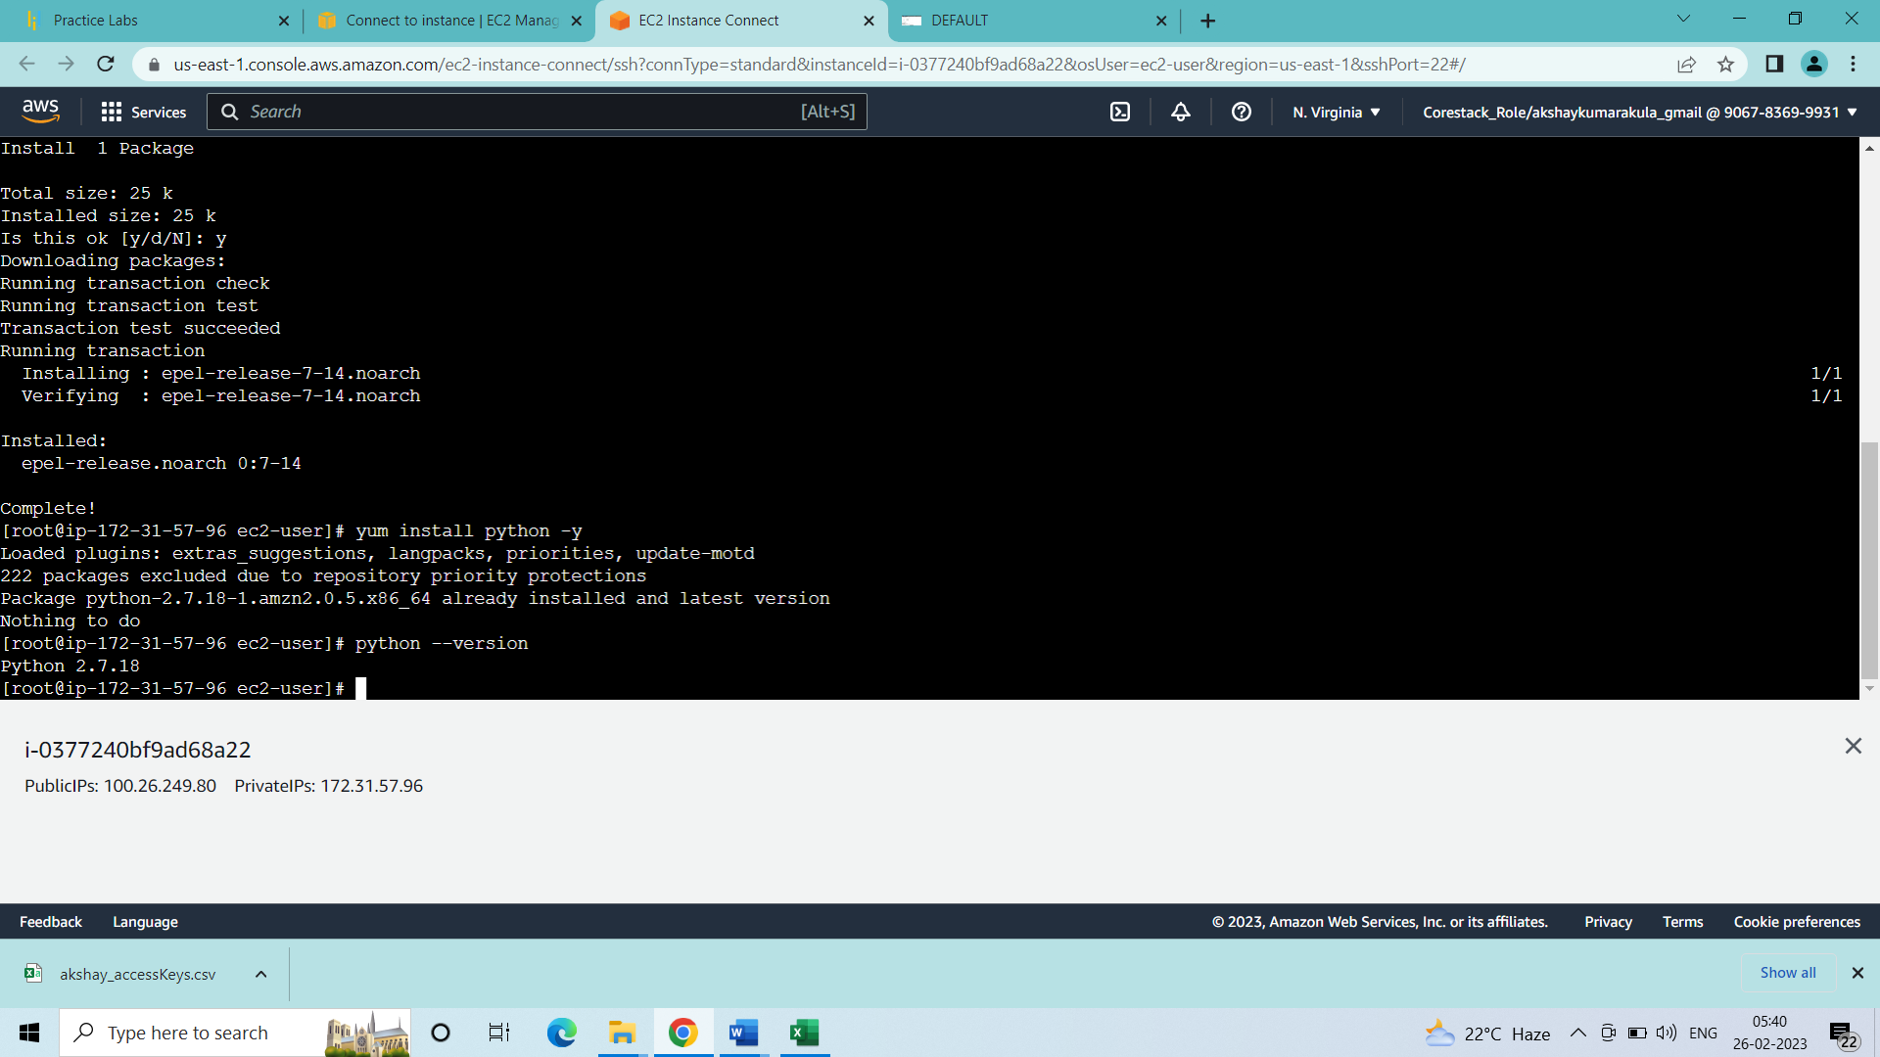

Python is installed

* Java installation:

sudo amazon-linux-extras install java-openjdk11 -y

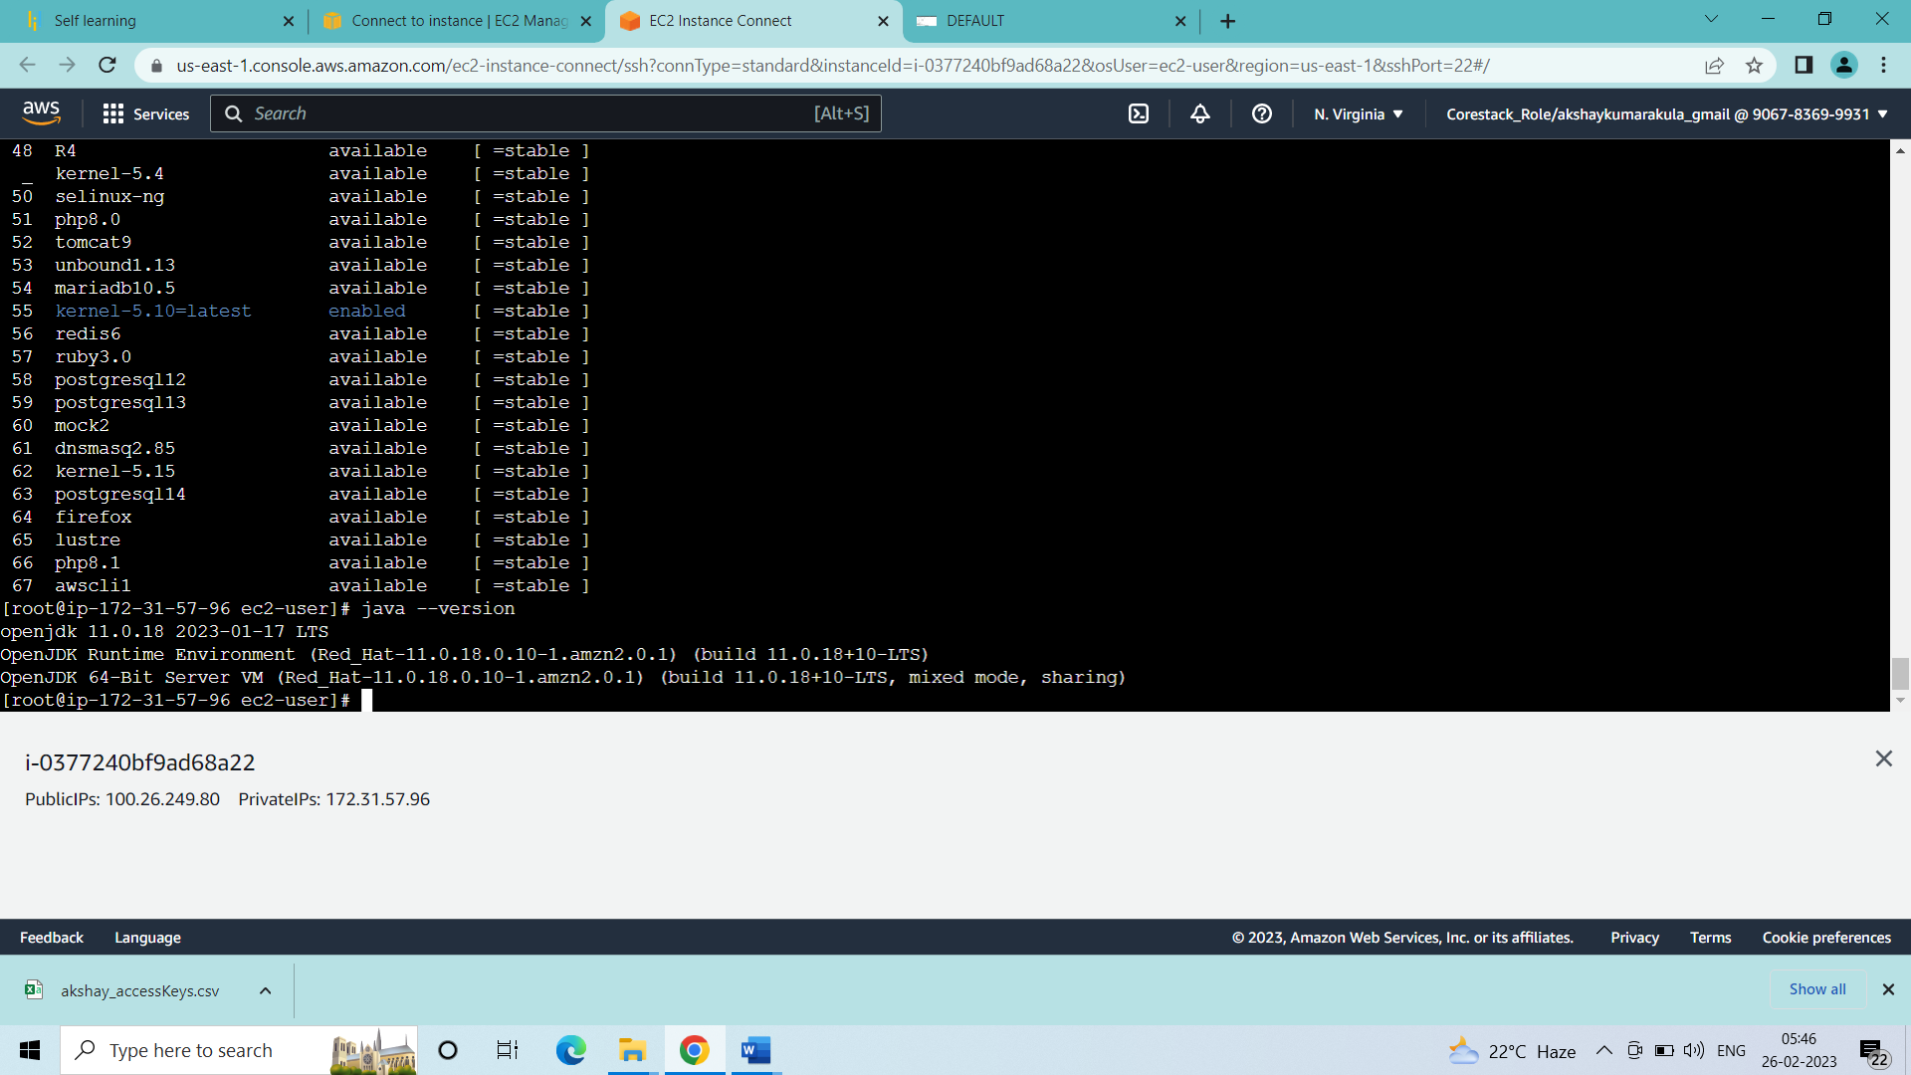

Java is installed

* Jenkins installation:

sudo yum update –y

sudo wget -O /etc/yum.repos.d/jenkins.repo \    https://pkg.jenkins.io/redhat-stable/jenkins.repo

sudo rpm --import https://pkg.jenkins.io/redhat-stable/jenkins.io.key

        sudo yum upgrade

sudo yum install jenkins -y

sudo systemctl enable jenkins

sudo systemctl start jenkins

sudo systemctl status jenkins

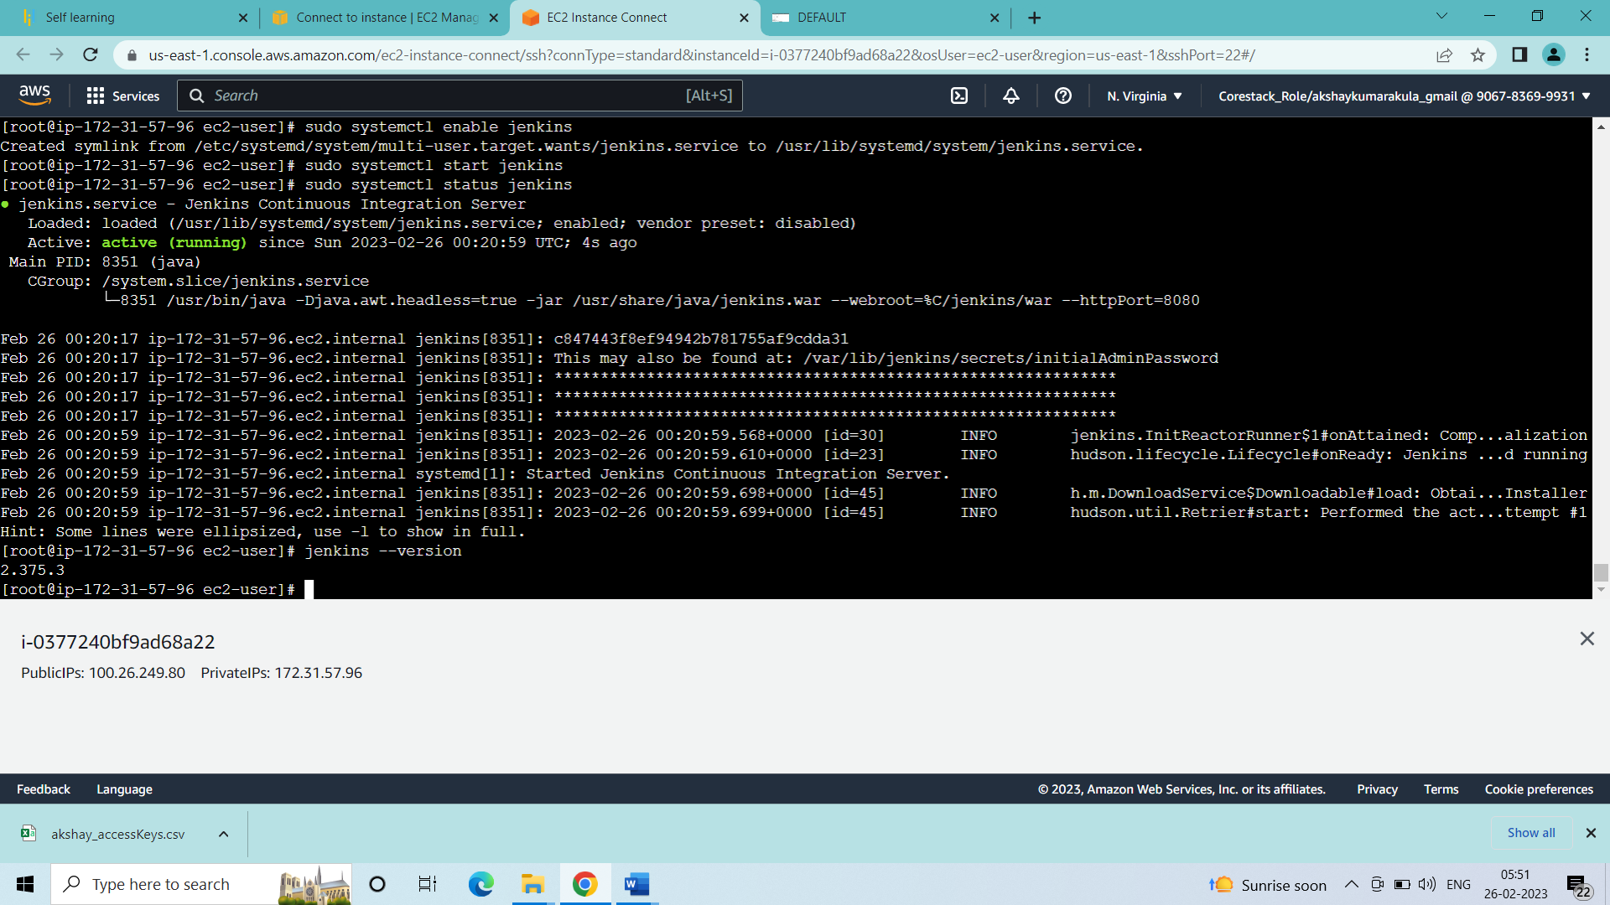

Jenkins is installed